The coronavirus.
By Sophie, Libby and Millie
What is the coronavirus?
The coronaviruses are a family of viruses that can cause illnesses such as the common cold, severe acute respiratory syndrome and middle east respiratory syndrome. In 2019, a new coronavirus was identified as the cause of a disease out break in china.
Symptoms.
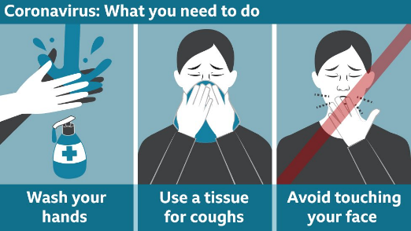
They can appear two – fourteen days after exposure and can include; fever, cough, shortness of breath or difficulty breathing. You should contact your doctor right away if you have COVID-19. It spread for a bad to a human.
How to stop the spread?
Wash your hands often with soap and water or use an alcohol-based hand sanitizer.
What is self-isolation?
Self-isolation means cutting yourself off from the rest of the world. You need to stay at home, not go to work, school or other public places, and avoid public transport or taxis, says Public Health England. "Common-sense" steps include staying in a well-ventilated room with a window that can be opened and keeping away from other people in your home. Ask for help if you need groceries, other shopping or medication. It's OK to have friends, family or delivery drivers drop off supplies to get you through. But you shouldn't have any visitors, PHE says. You can have deliveries left on the doorstep.
Do I need to self-isolate?
From Friday (13th march), everyone with flu-like symptoms - defined as a fever of above 37.8C or a persistent cough - is being asked to stay at home for at least seven days. Anyone who has travelled to an affected area, or who has been in close contact with an infected person, had already been asked to self-isolate for 14 days. Spending 15 minutes within 2m (6ft) of someone with the virus, or having face-to-face contact, is judged as close contact and a significant risk.
What if someone self-isolating shares a home?
If you are self-isolating and share a kitchen it is recommended that you ask someone to cook your meals for you and for you to eat them in your room and clean all the surfaces you are in contact with daily with household cleaning supplies. If possible stay 2m (6ft) away from other people and sleep alone.

Hackers and Profit on Corona
Hackers:
Cases in over a dozen countries have reported about hackers using different tactics to install dangerous malware on to computers and to steal personal financial information. These include infected emails with documents attached that promise new information on Covid-19 but instead steal credit card information by releasing malware such as Emotet- which is a trojan primarily spread through emails that is sent to collect banking details of the host.
A Japanese hacking group known as TA542 is known for using software like Emotet; they claim to have information on new cases that have been reported but opening the attachment is only a way to spread this software.
Other methods of hacking include fake donation pages where the victim is convinced that their money is going to help scientists work on a cure for Coronavirus. In addition to emails that steal personal information, fake government web pages that claim to have important details on Corona and how to stop spreading the virus can steal your security information such as passwords, credit card numbers and other things saved in your browser.

Mainstream Profit
Because of the fear and misinformation around Corona, businesses and people have been able to profit off of vulnerable people and their knowledge of Covid-19.
Websites such as wish and celebrities such as Scott Disick are making apparel surrounding the Coronavirus outbreak. While some are created to spread messages about the prevention of corona, like Scott’s ‘please wash your hands’ shirts, others are made solely for profit.
In New Zealand, face masks and other protection methods such as respirators are being sold for an average price of $100 (£49) each and set of 4 travel-sized hand sanitizers can cost you prices ranging from $50.
Websites including Amazon and Esty have started removing Coronavirus themed merchandise and Amazon has been blocking not only overpriced corona related items but also anything with misleading information.

Coronavirus politics:
Recently the coronavirus has become a pandemic. The virus has spread very fast and there have been different views about what to do during this time. People has been looking towards politics to see what is going to happen. Boris Johnson gave a speech about the virus on the 12th of March after holding a press conference. In what he said, he spoke about how it is “the worst public health crisis for a generation.” Boris went on to talk about the coronavirus in more detail. The part of the speech that struck most people is when he said that “many more families are going to lose loved ones before their time.” The coronavirus has currently killed 10 people in the UK and won’t be stopping anytime soon. Boris said “we have a clear plan that we are now working through and we’re now getting on to the next phase in that plan because this is not an attempt to contain the disease as far as possible, but to delay it’s spread and thereby minimise the suffering.” It is predicted that the UK will go in lockdown before the Easter holidays.

The coronavirus has also caused some worry regarding the elections in May. People are saying that they should be postponed to Autumn. They are due to happen on May 7th but the Electoral Commission says that is has “become clear that the risks are so significant as to raise serious concerns about the polls continuing to their current timetable.” The concerns are getting serious as this dangerous virus spreads faster and affects more people.

