GCSE’s – Promising children a future, or ruining it before they’ve even had a chance?

GCSE’s have always caused controversy on a global scale; from the pupils themselves, to parents and carers, all the way to the government. With the importance of GCSE’s on a child’s future frequently increasing, so does the stress and pressure on adolescents, leading to mental health issues which drastically affect every child they inflict. 1 in 5 young people suffer with a common mental health problem, such as anxiety or depression, what if that child was yours?

Half of all mental health conditions start by fourteen years of age, but most cases are undetected and untreated. It is no coincidence that fourteen years of age is when students will start to receive the importance of their GCSE courses and how their results will impact the future. For a young person - developing and changing - this added pressure is completely unneeded. Mental health isn’t a phase and won’t just go away! Mental health conditions will stay with you, from a young child, to a teenager, to adulthood and onwards. If GCSE’s are causing mental health problems - are they really worth all of the fuss?

You may be thinking, “well surely children should be able to get their conditions treated”, but realistically it’s not that easy. There is a major lack of help available to young people who have mental health problems, with 75% of young people who are experiencing these not receiving help and those who are having to wait ages to get desperately needed treatment. Money and supplies just aren’t available. With majority of schools not having a guidance councillor, a absolute necessity to help prevent and fight teen mental health.

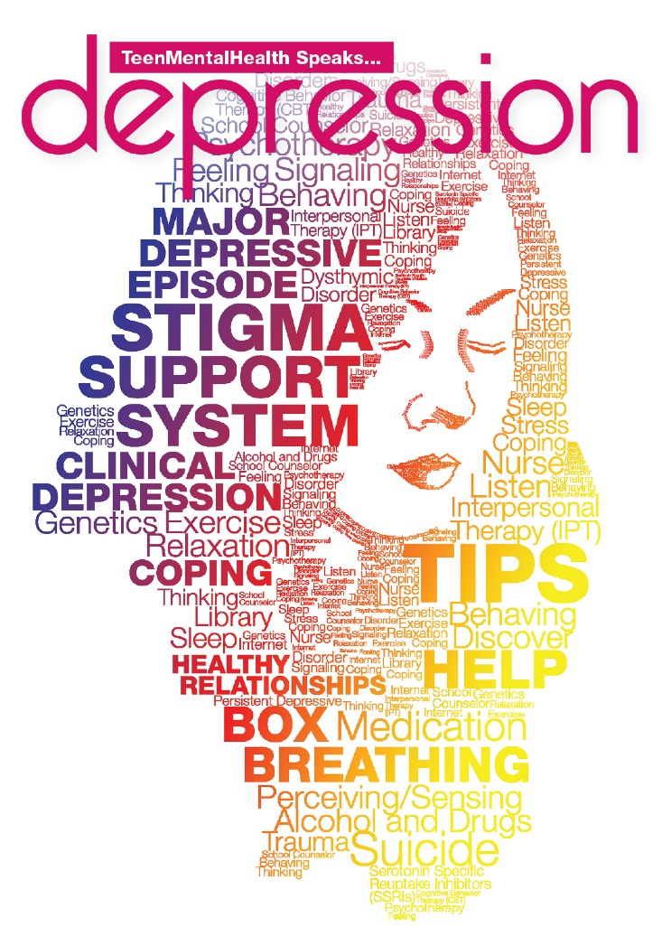
In terms of money… What are the government doing to prevent these conditions from rising? GCSE’s seem to be having very little changes made to them, especially as staying in education is now compulsory till you are eighteen. Apparently nowadays, grades are the ‘be all and end all’ of a child’s future career. On the 7th October 2019 the government-backed a £35 million research programme with aims to give more support to teens with mental health issues and allowing academics to look at external tensions and genetics to ensure mental health problems are treated as effectively as possible. Business secretary Andrea Leadsom said “the £35 million government-backed research programme we are announcing today will look to better understand why so many teenagers face mental health problems, and we can better support, detect and treat them.” Though it is explicably clear that GCSE’s are a strong impact on teen mental health, the money being funded by the government promises a change for teens in turmoil. The NHS Long Term Plan is also being backed by an extra £2.3 billion a year enabling around 345,00 more children and young people to have better access to mental health by 2023-24. Furthermore, another promising factor towards mental health is the government making it mandatory to study the new health education curriculum from September 2020.

Though help is being offered, the real problem is not being addressed. GCSE’s. Most state school headteachers think that GCSE’s should be overhauled or scrapped as they lead to an increase in a child’s anxiety and mental health problems. With so many issue arising due to GCSE’s, surely a change is not only wanted, but desperately needed! How would you feel if your child grew up with mental health issues, and continued to have these throughout adulthood because of their exams? GCSE’s really do seem to ruin a child’s future more than they create one for them.

For any further help on mental help:
Priory - 0808 301 2190 (ask for Family Life for parents to children)
NHS – 111
Mental Health Foundation (Website)
Childline – 0800 11 11

