9th March 2020

Dear Parents,

**Ski Trip**

I know that coronavirus continues to hit the headlines. The messages and advice have changed substantially today in terms of travel especially about our foreign trips. We know tonight that Interski will no longer take the trip to Italy over the Easter Holidays. Mr Harris; our lead on this trip; will correspond with the parents of the students concerned.

**General Advice**

In terms of our general approach to the coronavirus outbreak we are supporting our students and staff by the following actions. Please rest assured that we have been in constant touch with the LA and their Public Health England workers and we have take daily advice from the gov.uk updates.

In school we have continued to support students and staff in making good choices about handwashing and hygiene in line with guidance. We have posters up around school and the information is on the plasmas too. Students have been reminded about good handwashing and how to deal with sneezes and dirty tissues.

Extra hand sanitisers are in the bridge hall and the dining hall. We have been able to source some more; as with everyone else the demand is currently much higher than the supply can cope with. We do have lots of soap and we are still told that using soap and water is the best way to stop the spread.

The following information and advice from the government has been shared. It is still the most pertinent advice.

**Do I need to avoid public places?**

Most people can continue to go to work, school and other public places.

You only need to stay away from public places (self-isolate) if advised to by the 111 online coronavirus service or a medical professional.

**How to avoid catching or spreading coronavirus**

**Do**

* wash your hands with soap and water often – do this for at least 20 seconds
* always wash your hands when you get home or into work
* use hand sanitiser gel if soap and water are not available
* cover your mouth and nose with a tissue or your sleeve (not your hands) when you cough or sneeze
* put used tissues in the bin straight away and wash your hands afterwards
* try to avoid close contact with people who are unwell

**Don't**

* do not touch your eyes, nose or mouth if your hands are not clean

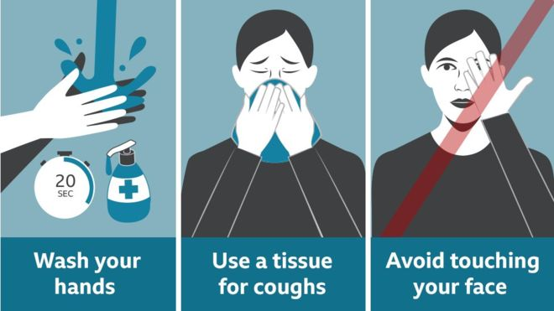

We have a nominated person in the LA who is on hand for queries and advice; we are in daily contact and from last Tuesday 3rd March they are sending the government updates directly to me. There has been some change since last week. The main change is about visits to certain regions and countries as stated at the start of this letter.

A link has been given for the government website and its latest advice and it is on our school website.<https://www.gov.uk/government/publications/guidance-to-educational-settings-about-covid-19>)

**Returning From Abroad**

If staff or students return from a place where infection is then they need to call 111 for advice. We hope that you will cooperate with this totally and thank you for doing so.

Attendance is aware of the advice especially over people returning from certain areas; this is both Miss Elsmore at school and our EWO.

**School Trips Abroad**

We are in liaison with the LA about trips abroad. The Diocesan Pilgrimage to Lourdes at May is still set to go ahead. The travel company Tangney Tours and the Diocese is that the pilgrimage currently will go ahead. At a meeting on 9th March 2020 leaders were informed that the pilgrims who stay in the accueil will not be attending. This means schools will ask questions as to whether or not they will still attend. We have some discussions to have with all relevant parties and a couple of weeks to make a final decision. Please be patient with us; we will communicate directly with parents of this group and will update you shortly.

I am liaising with the LA over foreign trips that are due out before the end of this academic year, namely the trips to Geneva and Poland. Please allow is to sort in a timely manner and as we are in possession of the facts and so we can make informed decisions.

For the first time today the summer exams  for our year 11s and 13s today have been referred to on the gov.uk website. “*We recognise that students, parents, schools and colleges will be concerned about the possible impact of coronavirus on the 2020 summer exam series. Ofqual’s advice at this time is to continue to prepare for exams and other assessments as normal.*

*Ofqual continues to work closely with exam boards, other regulators and the Department for Education to plan for a range of scenarios, as the public would expect. Our overriding priorities are fairness to students this summer and keeping disruption to a minimum.*

*It is still many weeks until exams start and we will issue updated advice if necessary, giving schools and colleges as much notice as possible.”*

This is the link.

<https://www.gov.uk/government/news/updated-statement-on-coronavirus>

**Cleaning and Catering**

Our contractors namely the cleaners and the caterers have their own procedures. Fidelis, the cleaners are ensuring that daily there is more intensive cleaning with an antibacterial cleaner over areas that have daily contact with hands e.g. handles and rails. They are in very regular contact with us and can provide us with a deep clean if we need one.

Caterlink continues to follow hygiene procedures and again they keep regular contact with us.

**Mass and the Chapel**

In accordance with the Catholic Bishops of England and Wales we will change our practices in Mass and services in the Chapel as follows.

* That we all wash our hands or use sanitiser before Mass.
* Communion will always be taken by our hands and given so that the host is placed on a hand without the priest or minister touching the hand and not taken by mouth.
* We will not have offertory processions to limit the number of people who touch the sacred vessels.
* The sign of peace is suspended but we can smile and nod at those nearby.
* The Holy Water is not used at the front of the chapel.

We thank you for your support in these uncertain times.

Yours sincerely,

Pauline Hanrahan