Smallest dinosaur discovered: The Oculudentavis Khaungraae
Recently a shocking discovery has occurred; one that could unfold the answers of how birds scientifically evolved from dinosaurs. Given the name Oculudentavis Khaungraae, (derived from the Latin words “eye, tooth“ and “mouth“) is a discovery that came to the surprise of many scientists, taking the lead as the smallest dinosaur from the Mesozoic era, and the current smallest known dinosaur.
The Oculudentavis Khaungraae was discovered fossilized in 99-million-year-old amber, the only part of the creature that was distinctable from this specific fossil was the skull, which was measured and discovered to be only 14 millimetres long, and only the width of a thumb nail!
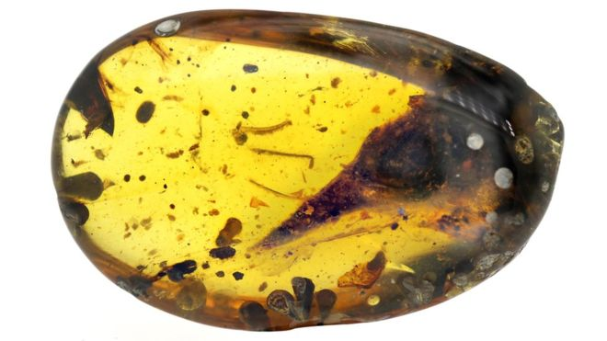
This minute creature was hypothesized to be only the size of a bee, and the time that the fossilized one passed it was nearing or at the stage of adulthood, making its petite structure all the more curious. Scientists have made a guess that a process called “island dwarfism” is the reason that it is so small; this process is which the species significantly shrinks upon generations. Its snout was filled with a set of 23 teeth- each no longer than half a millimetre. 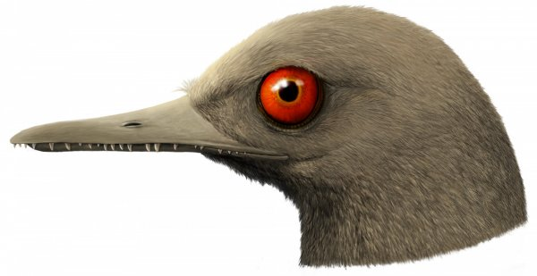
A guess of what the Oculudentavis Khaungraae would have looked like.

This creature has been enquired to be mostly related with the feathered dinosaurs of Archaeopteryx and Jehlornis, which are distant cousins from modern birds, and the most related modern-day bird is the tody, a small bird that fed on insects. The tody’s skull, however, is two times larger than the Oculudentavis Khaungraae, so it remains uncertain.
It still remains a mystery to how it’s related to modern day birds itself, or if it could even fly, although it was discovered that it had feathery wings. It seemed to feed on insects and other small vertebrates. Apparently from research it would be native to northern Myanmar. There was also a fossil that could have potentially held fossilized wings of the Oculudentavis Khaungraae, but it wasn’t too clear so nothing could have been proven.
Its eye structure seemed to be very peculiar as the bones of them would form the shape of a cone, like an owl. This suggests that the Oculudentavis Khaungraae would have exceptional vision, even for its size. The structure of the eye itself seemed to be curiously similar to those in a few lizards- the eye would even be so big that it would bulge out of either end of the head. This such vision would be perfect for a creature like this to find prey in the foliage it lived in. It has been noted that the Oculudentavis Khaungraae has features like any other dinosaur sharing its era.
More information is currently being discovered, and one day I hope we can discover all that we can about the Oculudentavis Khaungraae!
-By Clara

