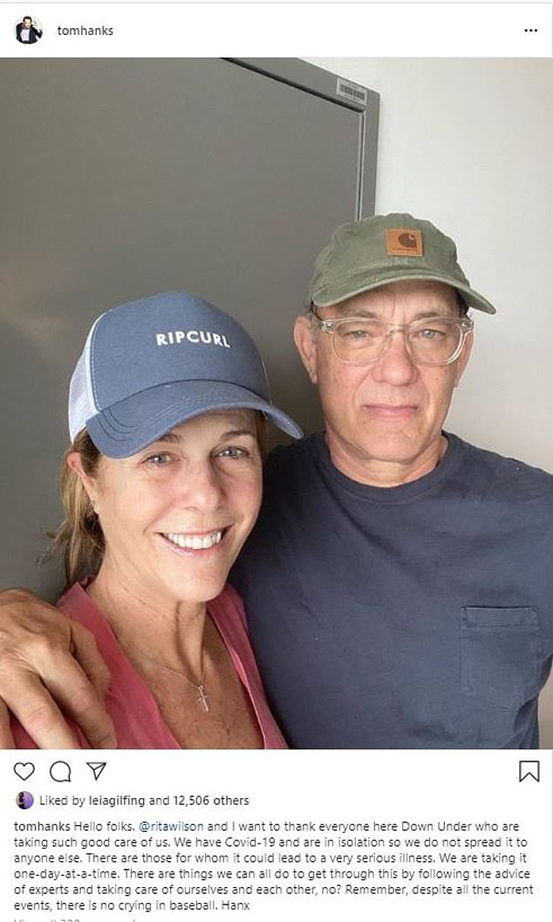
The 63-year-old Oscar winning actor has been tested positive for corona virus on Thursday. On social media he has spoken upon it and has brought light to a serious situation.
“Not much more to it than a one-day-at-a-time approach, no?” - @Tomhanks Instagram
The couple have been put into isolation at the Gold Coast University Hospital in Australia.
Warner Brother studios distributed a statement shortly after Hanks and Wilsons went public to say that health and safety of their company members is top priority.
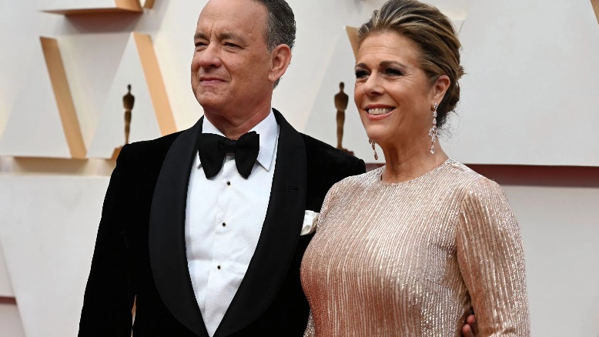
Among the notable names who responded to Wilson’s post was actress Kate Bosworth, who wrote, 'Love you;' and Kris Jenner, who responded, 'Praying for you and sending love to you both!!!' As well as other stars chiming in with kind words for the couple of 30 years included Naomi Campbell, Gwen Stefani, Julia Roberts and Kate Hudson.

