School Transport.
Our school is served by a number of bus services which the large majority of student use to travel to and from school. Students should aim to arrive in the morning at their designated stop at least 10 minutes prior to the scheduled arrival of the bus.
If a student misses the bus it is the parents' responsibility to make alternative arrangements.
The majority of services available run into Aldridge town centre from areas such as Walsall and Birmingham which is a pleasant 10 minute walk from school.
We also have a number of bespoke services which are run by National Express West Midlands which service the school by dropping off and collecting students on the school site, these are still public services. Students travelling from Lichfield use the reliable Diamond service number 35 which again is a public bus service dropping off and collecting in Aldridge town centre.
Students who travel from Tamworth have the option of using a dedicated school service which is paid for via Parentpay and serves all areas of Tamworth across to buses (SFA 1 and SFA2) If you are interested in access this service please email the school business manager for more details, smorris@stfrancis.cc
Students have 10 minutes at the end of the day to leave class, visit toilets and then catch their bus home. If a student misses the bus, then they MUST tell a member of staff; the student will be given the opportunity to telephone home. The school will try to make other arrangements if no-one is in.
Details of the services described above can be found on next few pages, I would also recommend accessing the West Midlands National Express website for more details regarding services.

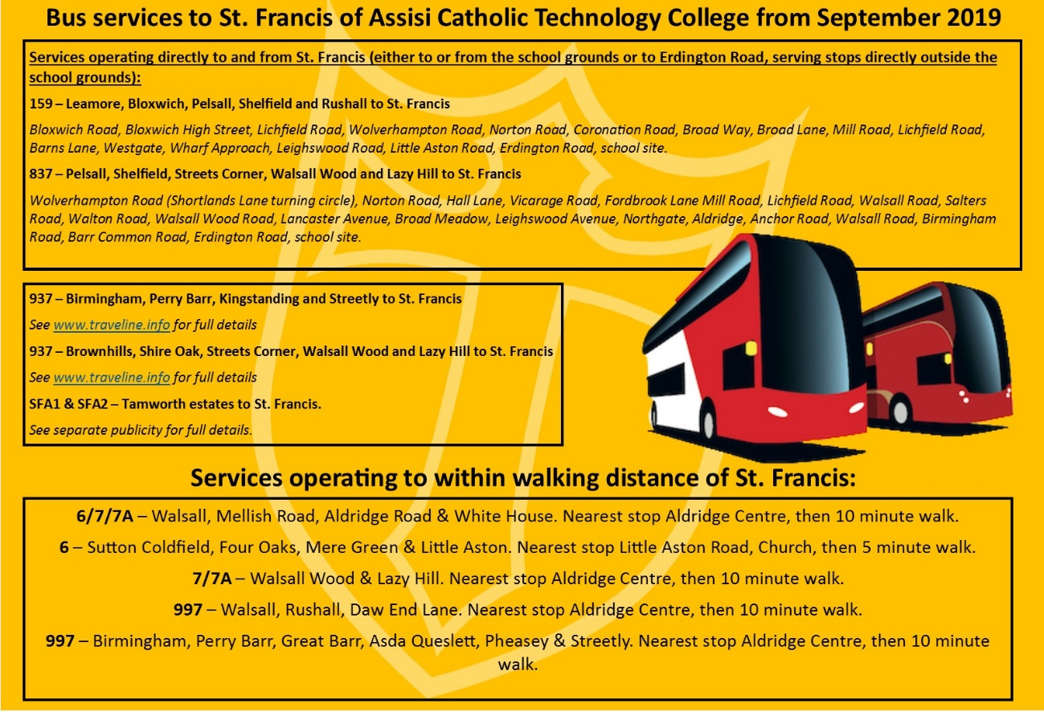

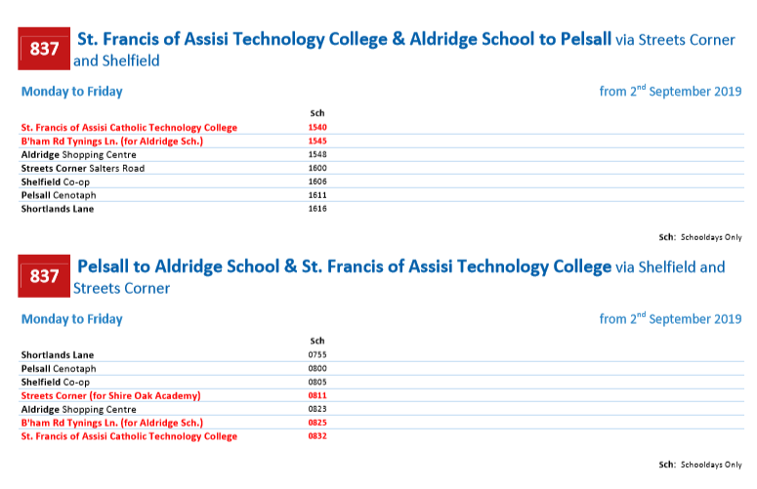
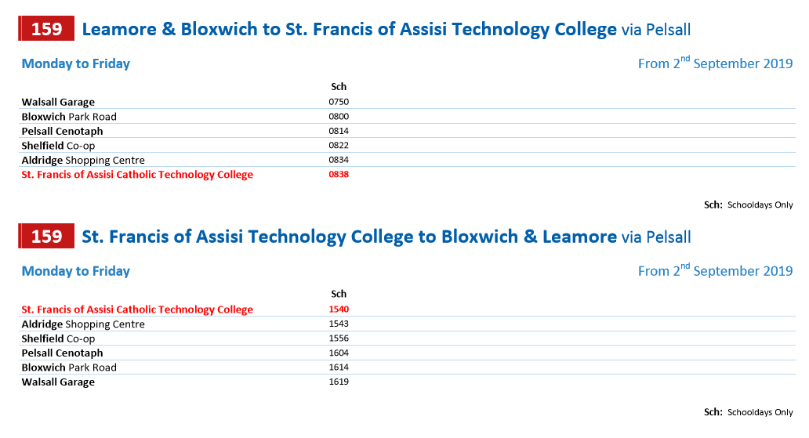

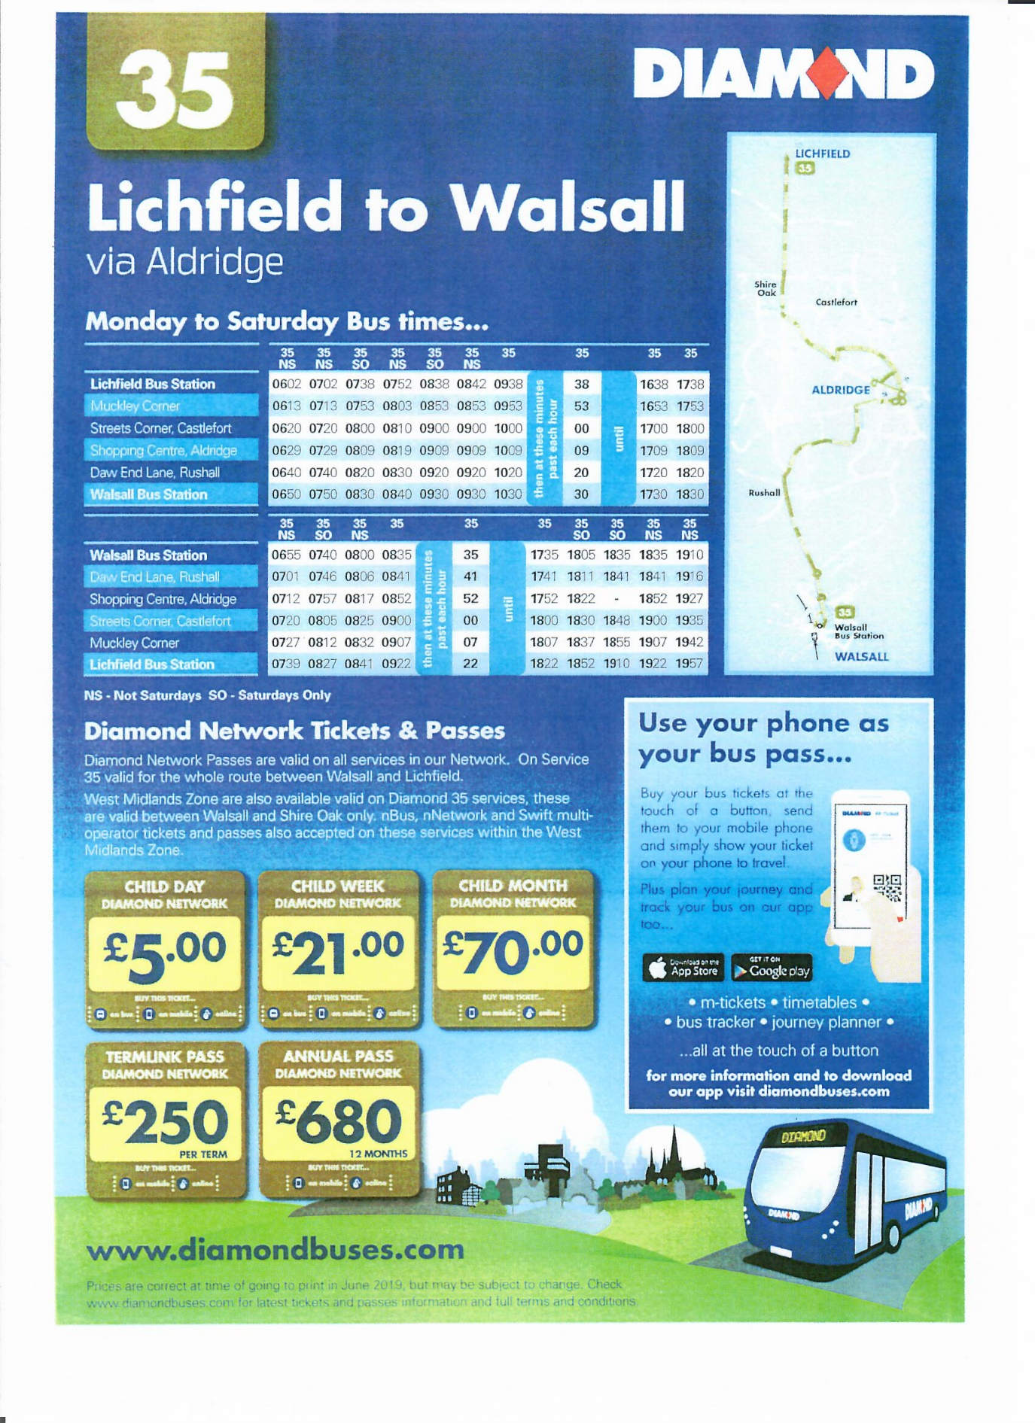

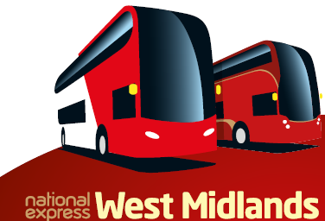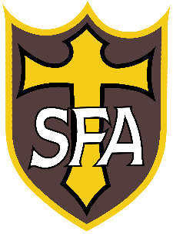

National Express – Tamworth Transport costs 2020-21

All payments to be made via the school ParentPay system, payments will be available in July 2019 on your parental account.
Any outstanding transport payment from 2018-19 needs to be settled on ParentPay before September 2019 to allow for the 2019-20 pass to be issued to students.

Weekly: £20
Monthly: £80
Termly: £250
Yearly: £750

Please be aware that the cost shown above is the cost of the seat to travel not a daily rate of travel.
Please be aware that if your payments are more than 4 weeks unpaid the National Express pass will be revoked until the account is brought back up to date.

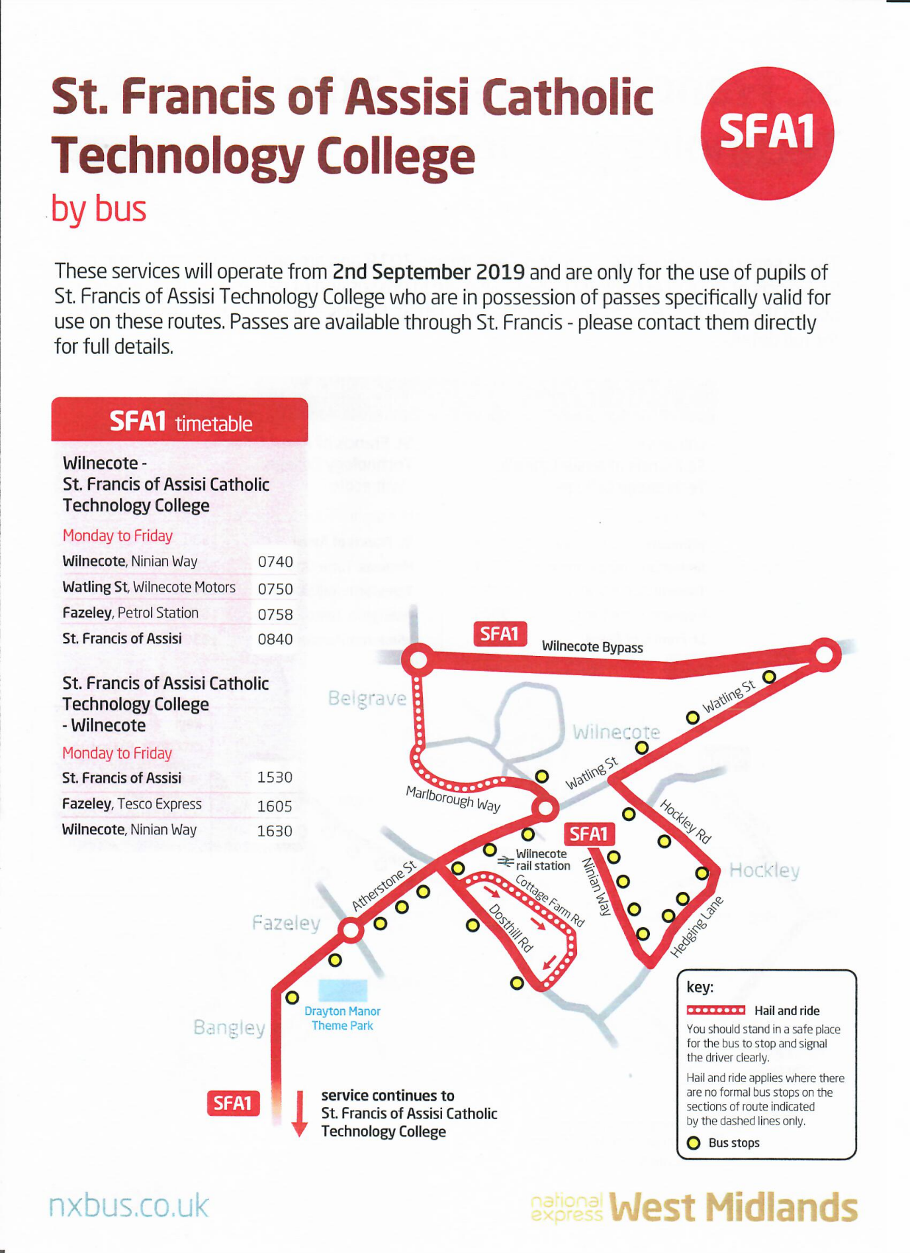

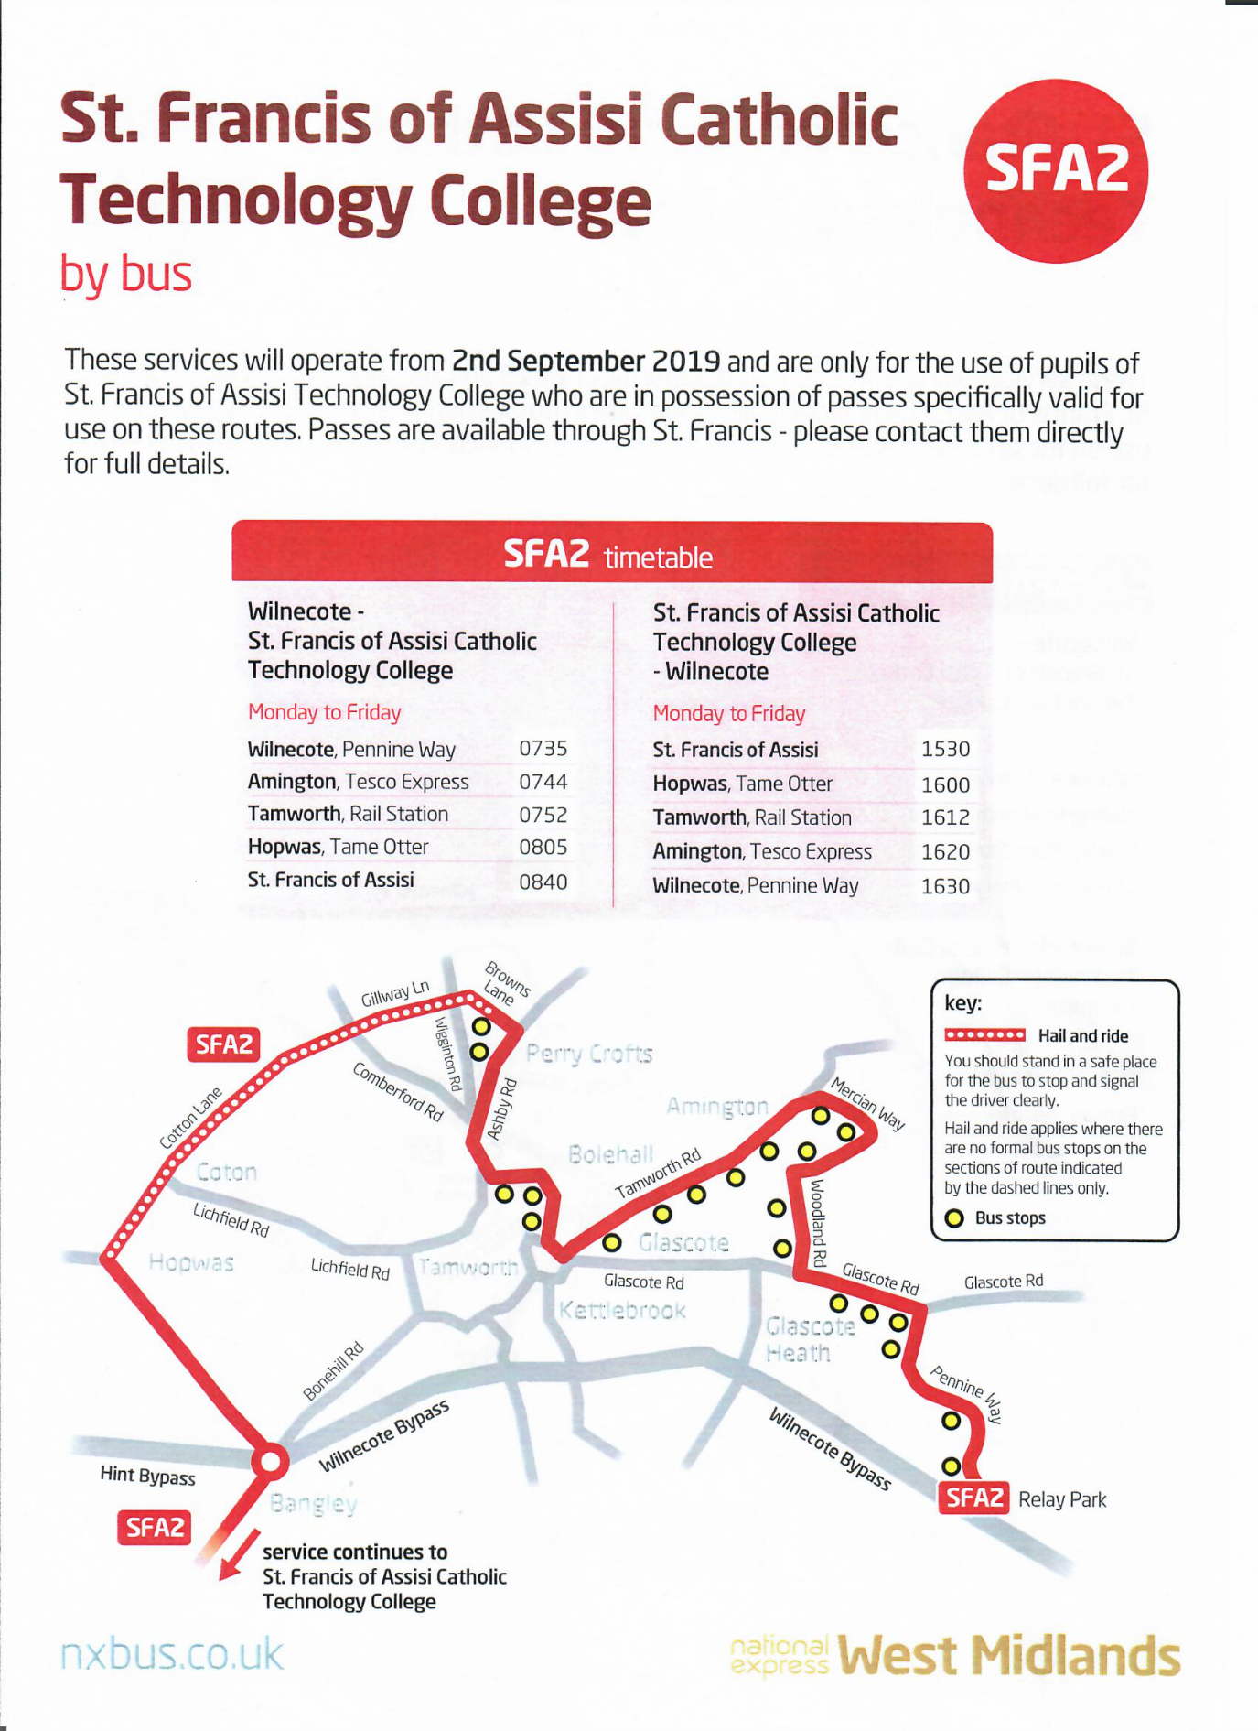

Helpful tips for catching school-service or
public-service buses

Getting on the bus...
If you are new to public transport, it’s a good idea to find the stop you will be using so you are confident you know where to go on your first day.
- Make sure you have the correct pass and or money.
- Remember to signal to the bus by putting your arm out as soon as you see the correct bus if you don’t signal to the driver they will not stop.

Please note, when sing a school bus you will have to adhere to the following code of conduct:
CONDUCT ON THE BUS
- Remember to show your pass to the driver (where applicable).
- Find a seat and stay seated for the journey. If there are no seats, hold onto the rail (where standing is permitted).
- If the bus has seatbelts, they must be worn.
- Do not distract the driver unless in an emergency.
- Do not damage the bus or interfere with the cctv or any other safety equipment.
- Photos should not be taken without the prior consent of the person(s) concerned - Always behave sensibly throughout your journey.
- Pupils causing concerns on the school buses will be placed on a Transport Contract or may be banned from using the buses altogether.

CONDUCT WHEN GETTING OFF THE BUS
- When your stop is next, ring the bell once. If it has already been rung, you do not need to ring it again.
- If you have to cross the road after you get off the bus, wait until the bus has moved off and you can see the road clearly in both directions, or go to the nearest available crossing.

TERMS AND CONDITIONS OF TRAVEL

You are respectfully reminded that when registering to use the service you undertake to accept the terms and conditions of travel. This includes sanctions, which would be applied if the re-quired standards of behaviour are not met. Parents need to be aware that if their child causes any damage or does not meet the required standard of behaviour on the bus they could:

- Have their pass withdrawn.
- Be banned from the bus.
- Be prosecuted by the police.
- Be required to pay for any damage they have caused.

Collecting students from school

For safety reasons, and to avoid congestion, we ask parents NOT to drive or park on the school premises between 3.15pm and 3.40pm in the afternoon to pick up their children.

Please also respect our neighbours when stopping/parking outside the school to collect or drop off children.

If you have to drive onto the school premises, then please note that there is a one-way system of traffic flow in operation on the school drive so please observe it and keep your speed down to 5mph.

AT ALL TIMES, WHILST DRIVING ON SCHOOL PREMISES, THINK SAFETY - PLEASE DRIVE SLOWLY.

