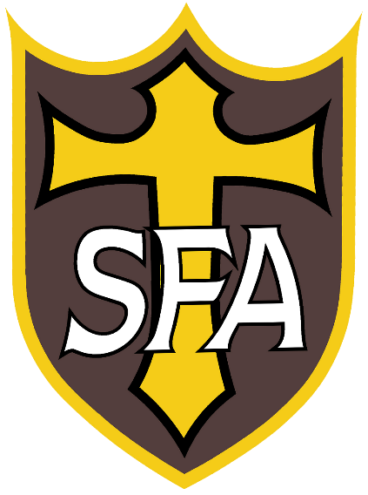

Completed application forms should be handed-in to Reception (Mrs K Hall). Alternatively, scanned versions may be emailed to post16@stfrancis.cc
The normal application deadline is Friday 8th January 2021 although applications beyond this date will be fully considered
Sixth Form Application Form 2021
St Francis of Assisi Catholic College

St Francis of Assisi Catholic College: Sixth Form Application Form For Entry in September 2021

A: Personal Information
Name:
Address:
Date of Birth:
Email address:
Mobile number:
Present school:
Religion:

B: Courses currently studied and target grades
Subject | Target grade

C: Reasons for applying to St Francis of Assisi Sixth Form
Tell us why you think you would make a great Sixth Former at SFA. Why you are drawn to our Sixth Form? Explain your subject preferences to study and what you can bring to our Sixth Form.
C: Subjects most interested in studying at Sixth Form
Please list the subjects which you wish to study in the Sixth Form – this is normally three subjects, you
can list more if you are unsure at the moment

D: Level 3 A Level or BTEC Subject choice
Students are asked to select any three of the subjects below. Please number 1-3 in order of preference (1 indicates your first choice subject). If you hope to study four subjects please put a fourth choice also

Subjects offered for  September 2021 | Choices  1-3 | Subjects offered for  September 2021 | Choices  1-3
Art A Level |  | Law (Applied) BTEC
Business Studies A Level |  | Mathematics A Level
Computer Science A Level |  | Media Studies A Level
Criminology Level 3 Applied Diploma |  | Music A Level
Design Engineering A Level |  | Physical Education A Level
English Literature A Level |  | Philosophy and Ethics A Level
French A Level |  | Photography A Level
Further Mathematics A Level |  | Product Design A Level
German A Level |  | Psychology A Level
Geography A Level |  | Science: Applied BTEC
Graphic Communication A Level |  | Science: Biology A Level
Health & Social Care BTEC |  | Science: Chemistry A Level
History A Level |  | Science: Physics A Level
ICT BTEC |  | Sociology A Level

E: Aspirations beyond Sixth Form
Briefly explain your longer term ambitions, career or degree plans

Completed application forms should be handed-in to Reception (Mrs K Hall).

Alternatively, scanned versions may be emailed to post16@stfrancis.cc

The normal application deadline is Friday 8th January 2021 although applications beyond this date will be fully considered.

