Sixth Form Application for 2022 Entry

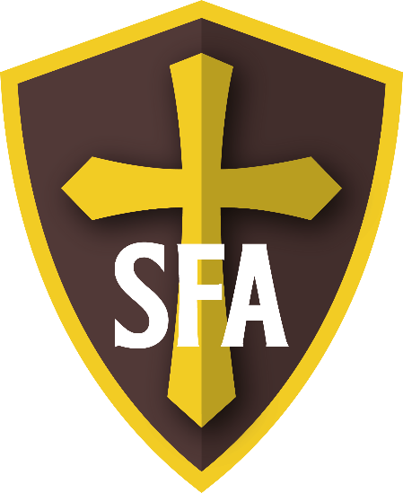

Completed application forms should be handed-in to Reception (Mrs K Hall).

Alternatively, scanned versions may be emailed to post16@stfrancis.cc

The normal application deadline is Friday 7th January 2022 although applications beyond this date will be fully considered.

St Francis of Assisi Catholic College: Sixth Form Application Form
Entry in September 2022

A: Personal Information
Name:
Address:
Date of Birth:
Email address:
Mobile number:
Present school:
Religion:

B: Courses currently studied and target grades
Subject | Target grade

C: Reasons for applying to St Francis of Assisi Sixth Form
Tell us why you think you would make a great Sixth Former at SFA. Why you are drawn to our Sixth Form? Explain your subject preferences to study and what you can bring to our Sixth Form.
C: Subjects most interested in studying at Sixth Form
Please list the subjects which you wish to study in the Sixth Form – this is normally three subjects, you
can list more if you are unsure at the moment

D: Level 3 A Level or BTEC Subject choice
Students are asked to select any three of the subjects below. Please number 1-3 in order of preference (1 indicates your first choice subject). If you hope to study four subjects please put a fourth choice also.

Subjects offered for September 2021 | Choices  1-3 | Subjects offered for September 2021 | Choices  1-3
Art A Level |  | Law BTEC
Business Studies A Level |  | Mathematics A Level
Computer Science A Level |  | Media Studies A Level
Criminology A Level |  | Music Technology A Level
Design Engineering A Level |  | Physical Education A Level
English Literature A Level |  | Philosophy and Ethics A Level
English Language and Literature A level |  | Photography A Level
French A Level |  | Product Design A Level
Further Mathematics A Level |  | Psychology A Level
Geography A Level |  | Science: Applied BTEC
Graphic Communication A Level |  | Science: Biology A Level
Health & Social Care BTEC |  | Science: Chemistry A Level
History A Level |  | Science: Physics A Level
ICT BTEC |  | Sociology A Level

E: Aspirations beyond Sixth Form

Briefly explain your longer-term ambitions, career or degree plans

Completed application forms should be handed-in to Reception (Mrs K Hall).

Alternatively, scanned versions may be emailed to post16@stfrancis.cc

The l application deadline is Friday 7th January 2022 although applications beyond this date will be fully considered.

